Week 1 Task DevOps intern

Task1: Ubuntu Installation
Installed Ubuntu using vagrant
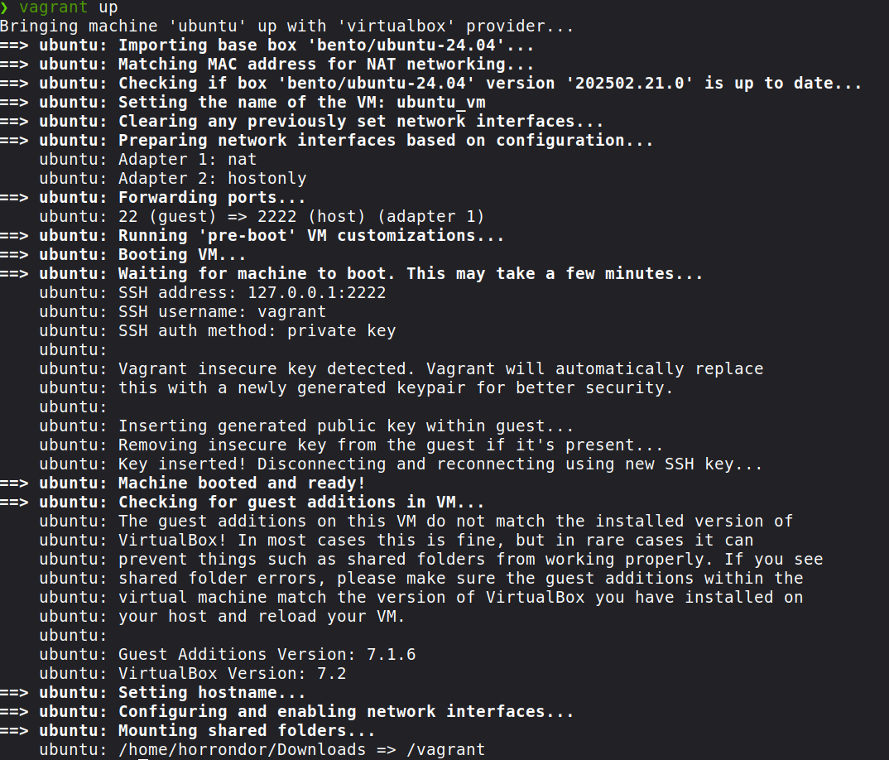
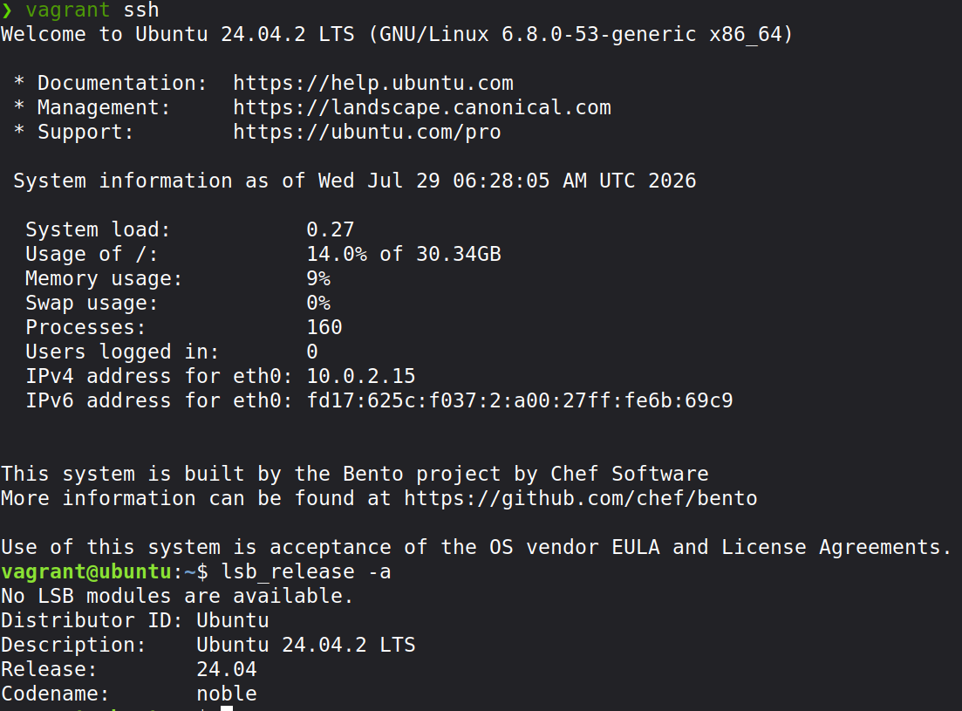
fig 1: Screenshot of ubuntu installation and linux terminal

Task 2: Create users and Groups

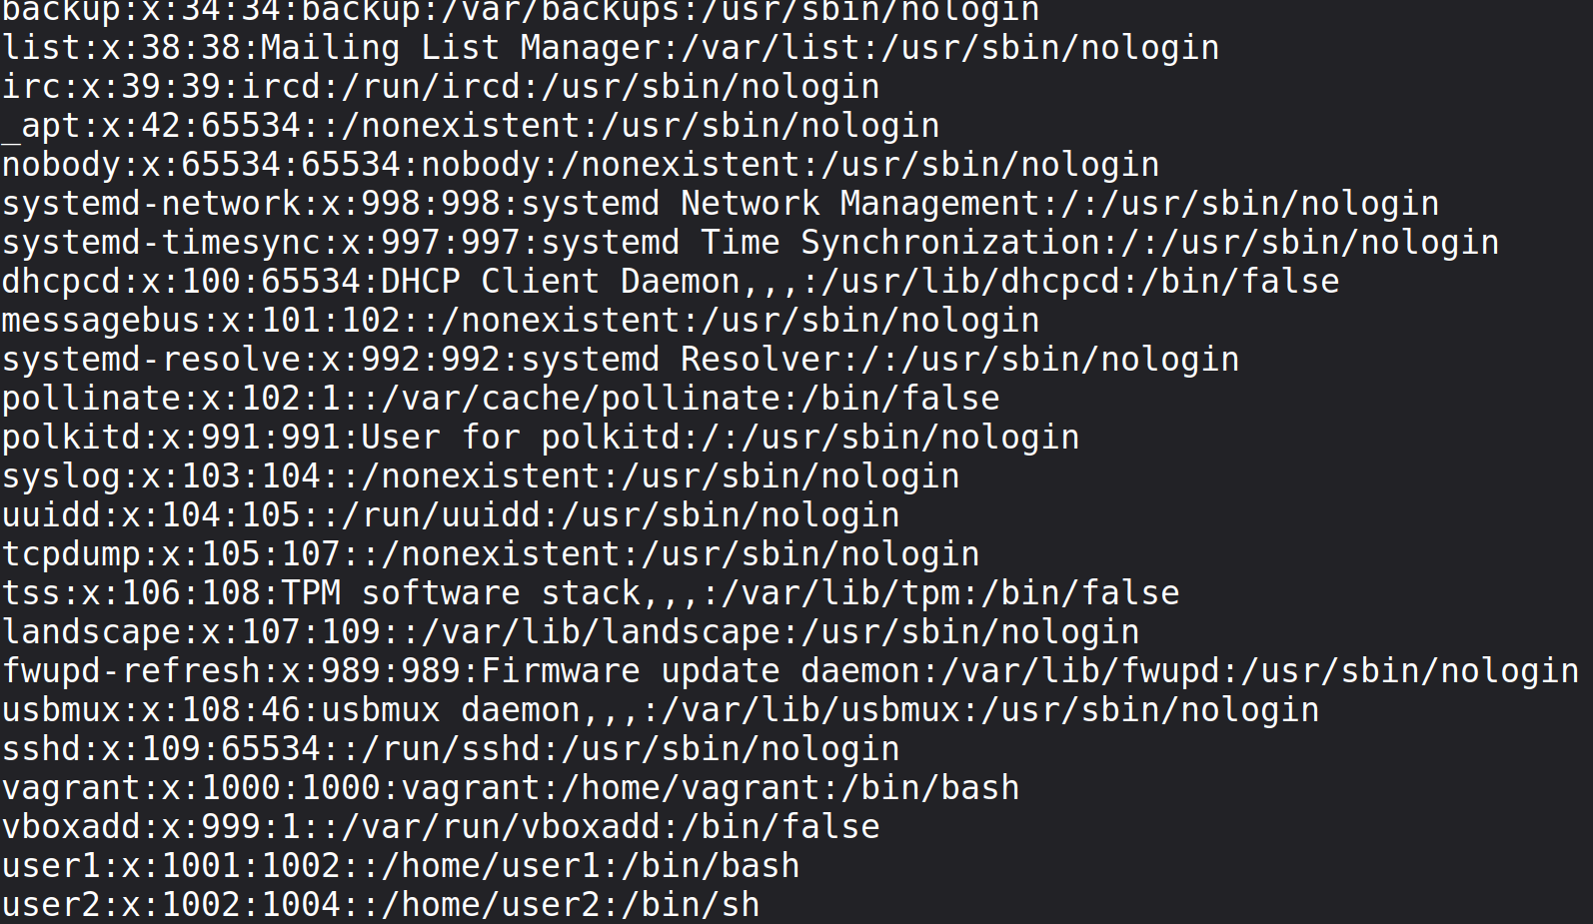
Fig 2.1: User lists
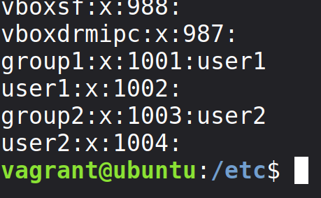

Fig 2.2: Group list

Task3: File Permission
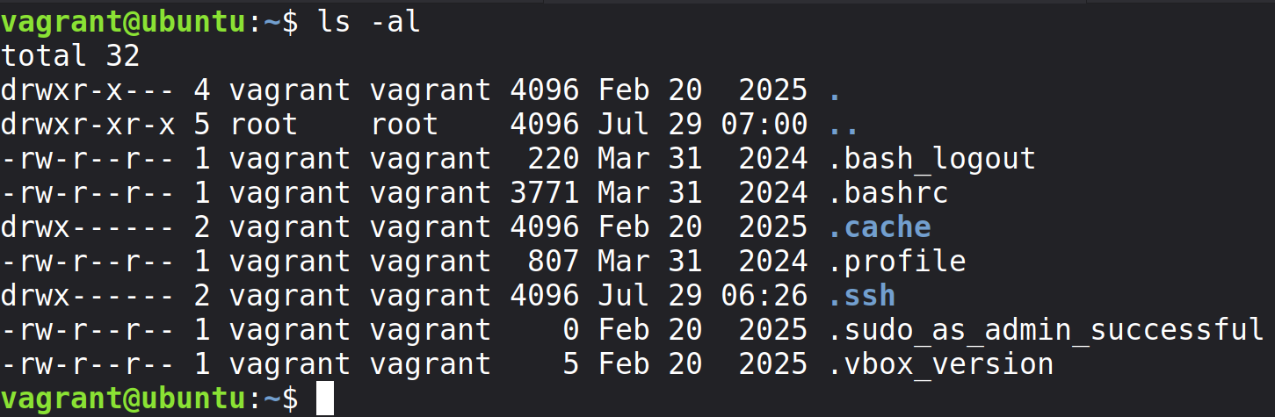
Fig 3.1: File permission

Task4: Networking commands

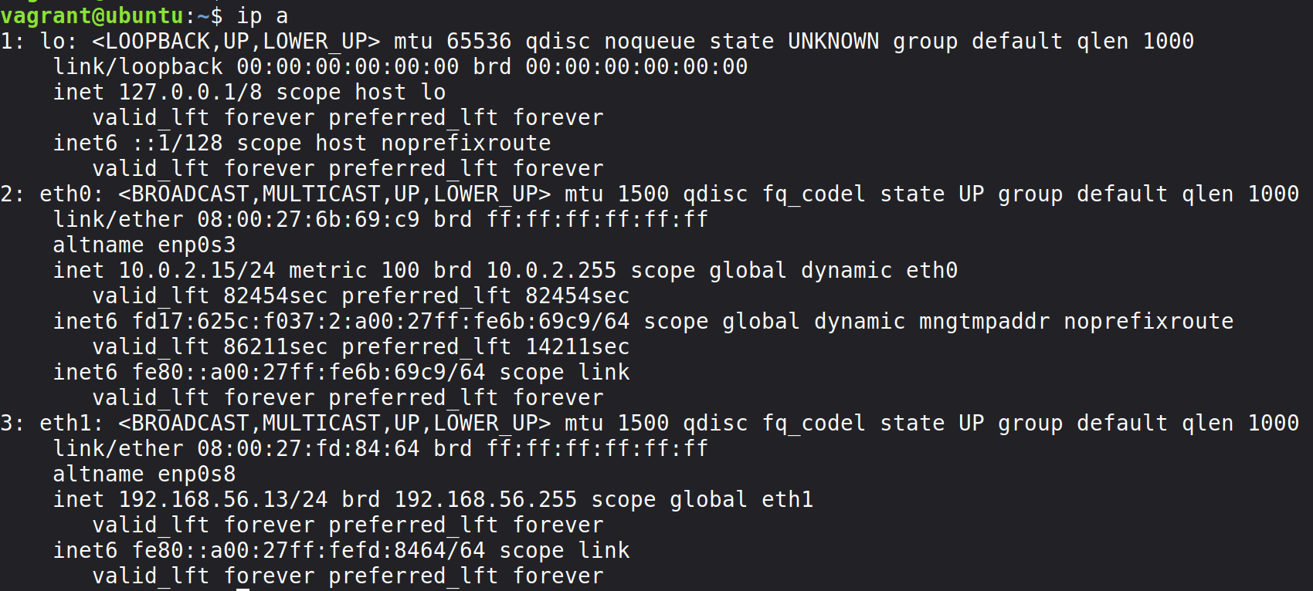
Fig 4.1: ip address show

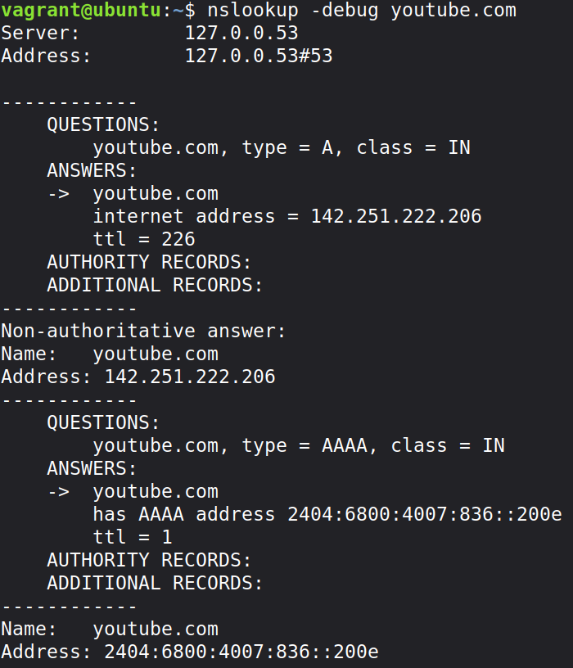
fig 4.2: Nameserver lookup

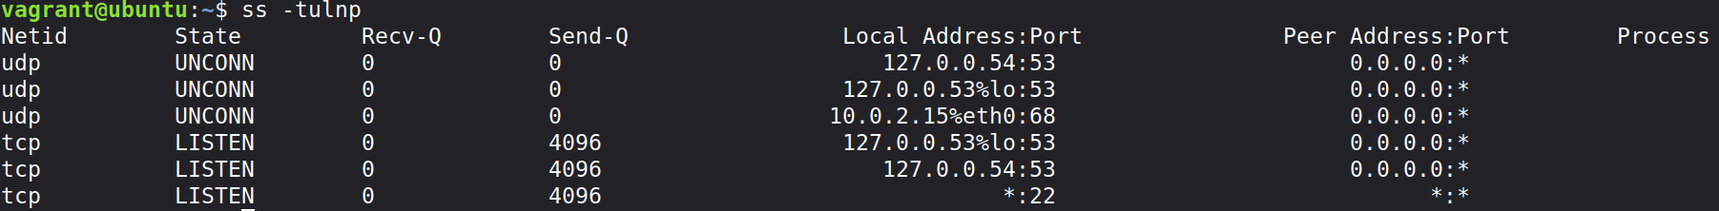
fig 4.2: Socket statistics

